INSTALLION OF DATA_INTEGRATION AND BISERVER

1. DATA-INTEGRATION :-

1.1) Install ubuntu :-

Ubuntu version :- 12.0.4 or above

1.2) Install mysql server:-

* open terminal in ubuntu and Type

command :- sudo apt-get update

command :- sudo apt-get install mysql-server

command :- sudo apt-get install ssh

command :-sudo apt-get install ssh-server

command :-sudo apt-get install mysql-workbench

* You can skip the step if java is already installed

1.3) Install Java :-

command:-sudo apt-get install python-software-properties

command:-sudo add-apt-repository ppa:webupd8team/java

command:-sudo apt-get update

command :-sudo apt-get oracle-7java-installer

* If you have many java configured and wand to choose newly installed java version as default

command:- sudo update-alternatives --config java

* now by typing the number you can set the default version of java.

1.3.1) Set JAVA_HOME

command:- echo 'export PATH=$PATH:/usr/lib/jvm/{java_version}' >> ~/.bashrc

1.4) install data-integration(stable release):-

Link:- http://sourceforge.net/projects/pentaho/files/Data%20Integration/5.0.1-stable/

* unzip the zipped file

command:-unzip [pdi-ce-5.0.1.A-stable.zip](http://sourceforge.net/projects/pentaho/files/Data%20Integration/5.0.1-stable/pdi-ce-5.0.1.A-stable.zip/download)

command:- echo 'export PATH=$PATH:{pdi folder}' >> ~/.bashrc

1.5) Download JDBC connector for database connection

Link :- http://dev.mysql.com/downloads/file.php?id=456317

* unzip the file

command :-unzip mysql-connector

* mv file mysql-connector-java-5.1.35-bin.jar to /home/arjun/data-integeration/lib folder

command :- cp /home/arjun/mysql-connector-java-5.1.35/mysql- connector-java-5.1.35.jar /home/arjun/data- integration/lib

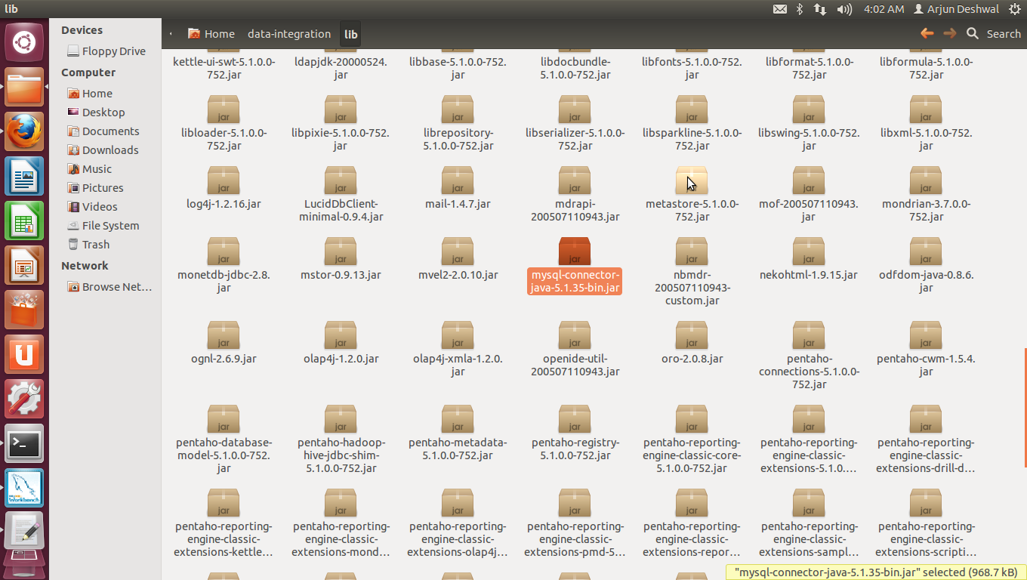

1.7) Configure hadoop for the data-integration

* Now download shim hdp20

Link :- https://github.com/pentaho/pentaho-hadoop-shims/tree/master/

* Unzip it and move

command:-unzip hdp20

command:- mv /arjun/home/hdp20 /arjun/home/data- integration/plugins/pentaho-big-data- plugin/hadoop-configurations

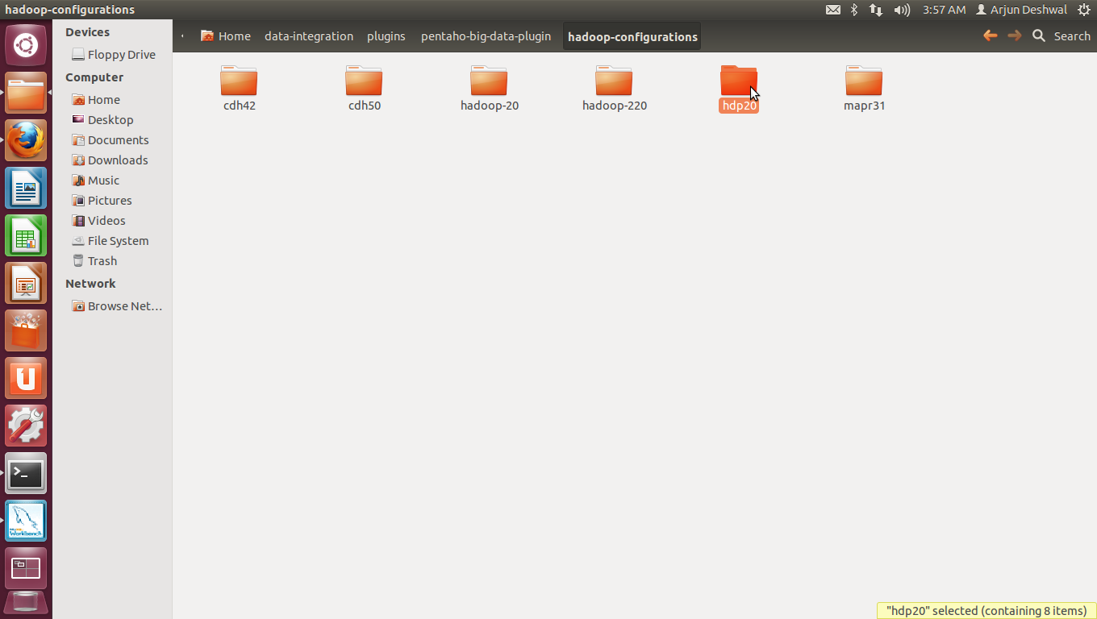

* change plugin.properties

open plugin.properties kept in :- /arjun/home/dataintegration/plugins/pentaho- big-data-plugin/

set:- active.hadoop.configuration=hdp20

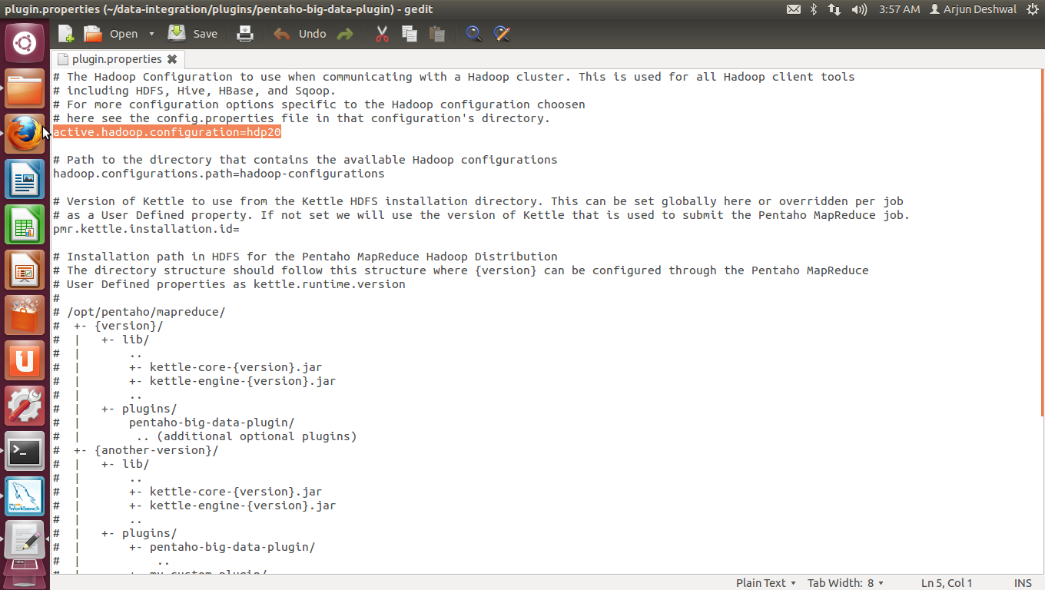

1.8) Run Spoon

* Run spoon

command:-cd /home/arjun/data-integration

command:- ./spoon.sh

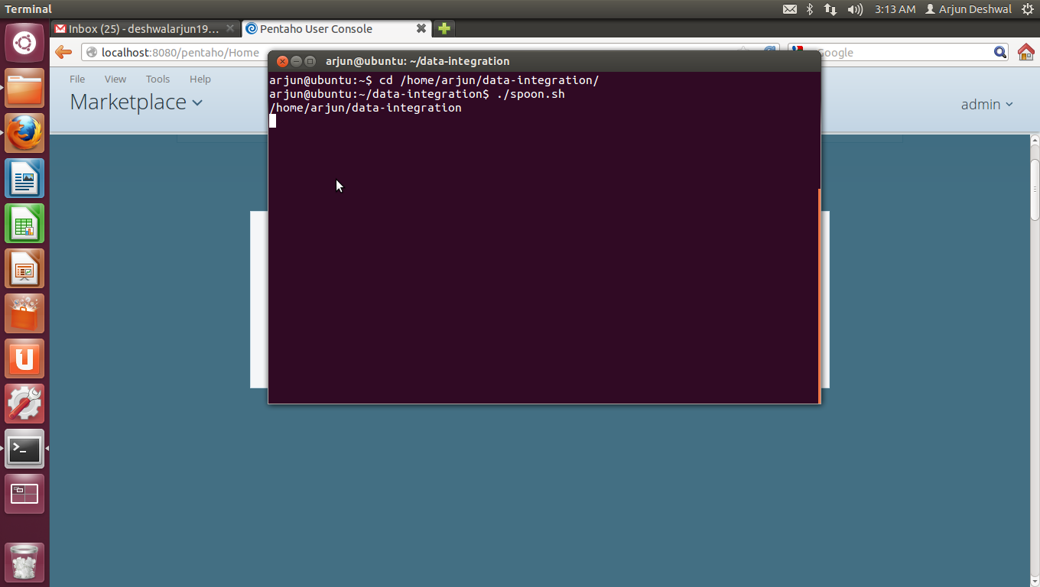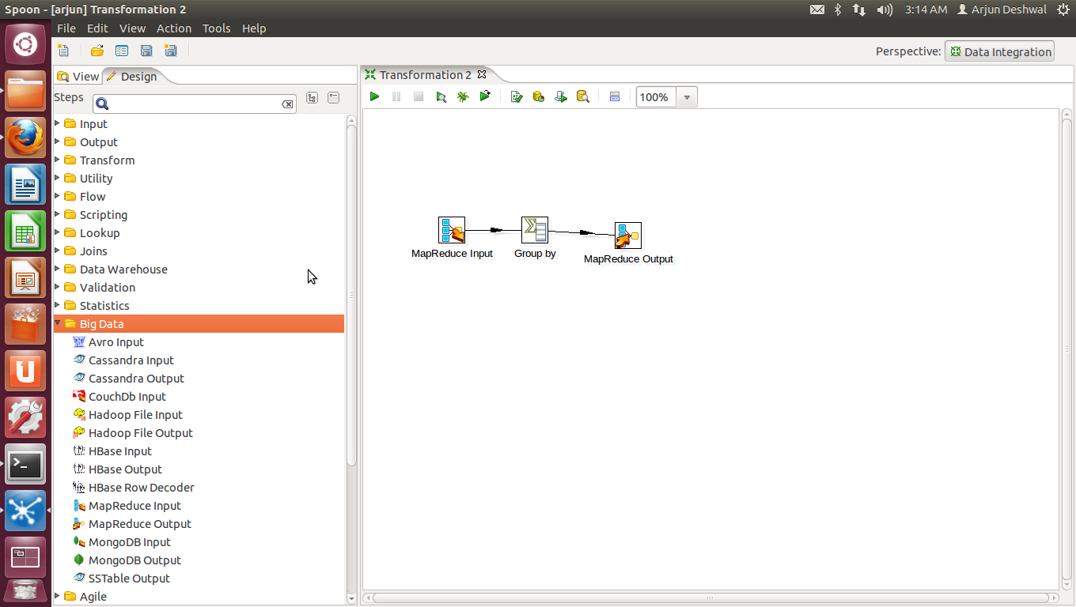

2) BI-Server

2.1) Download BI-server stable release

Link:- http://sourceforge.net/projects/pentaho/files/Business%20Intelligence%20Server/5.0.1-stable/

2.2) Run Bi-server

* unzip the folder

command:- unzip filename

* run biserver

command:- filename/start-pentaho.sh

2.3) open console

* You can visit console on

Link:- http://localhost:8088

